|  |
| --- |
| Report Delta Modulation |
| [Type the document subtitle] |
| Name : Sherine Sameh Abd elAziz ID:2141 Myriam Reda Dimitry ID:2159 |

4/15/2016

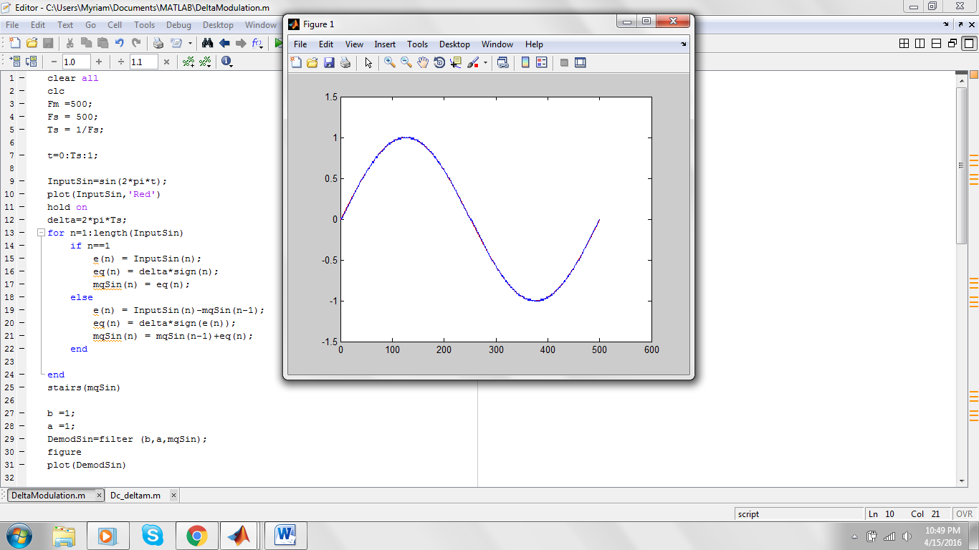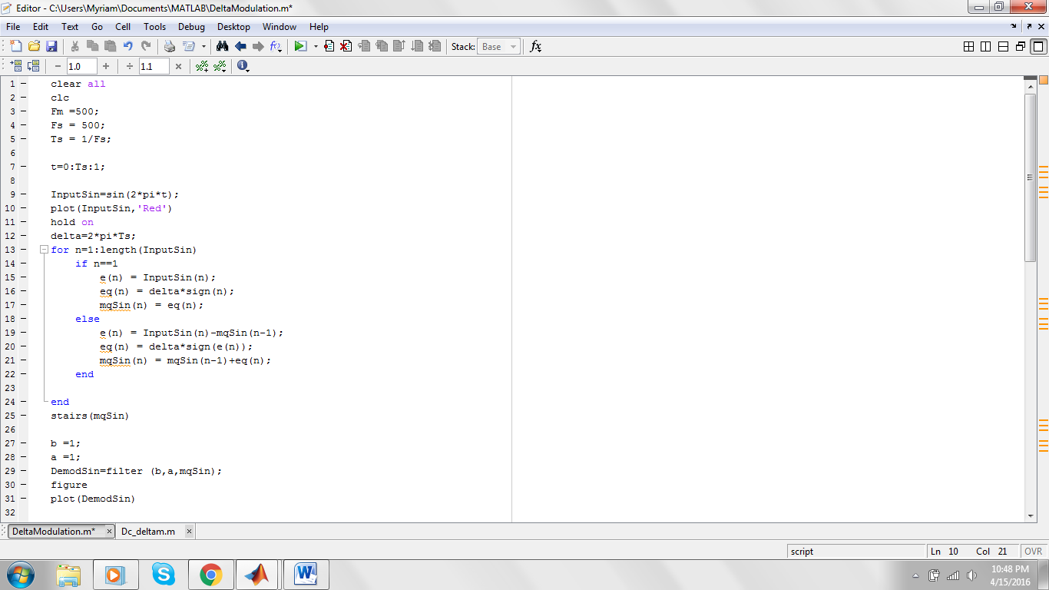**First**  Draw the sin wave with an Fm = 500 Hz

Having a suitable Ts and delta =

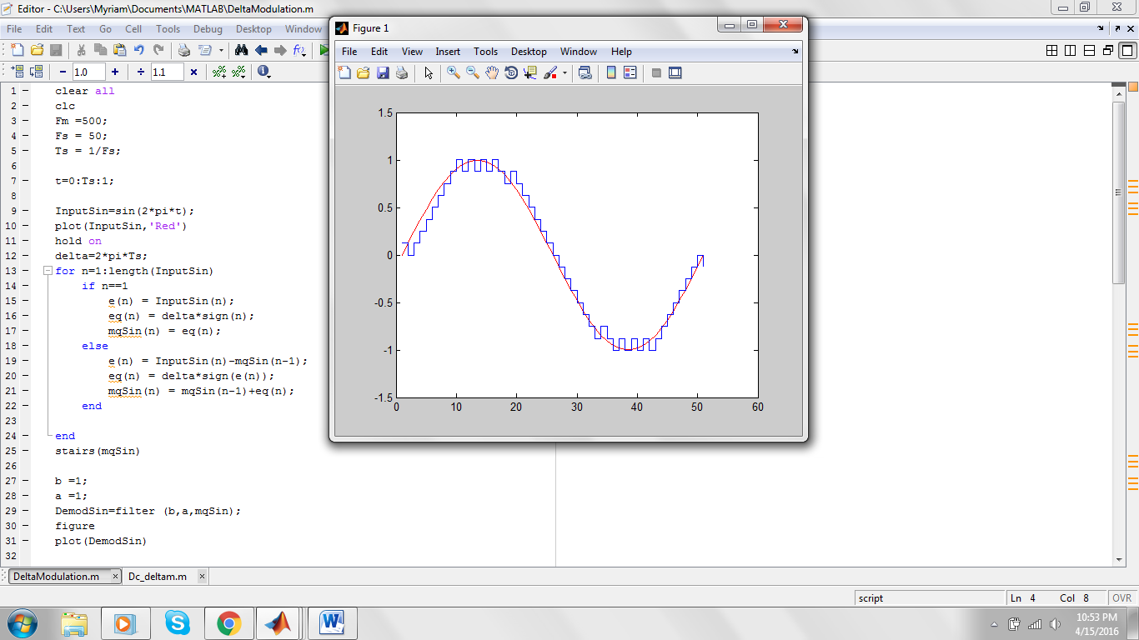Ts = 1/Fs ;

delta=2*pi*Ts;

**and the modulated Signal :**

as the Delta modulation is a special case from the DPCM

the idea is using one bit so it is either a 1 or a 0

1: is + delta

0: is - delta

**The code :**

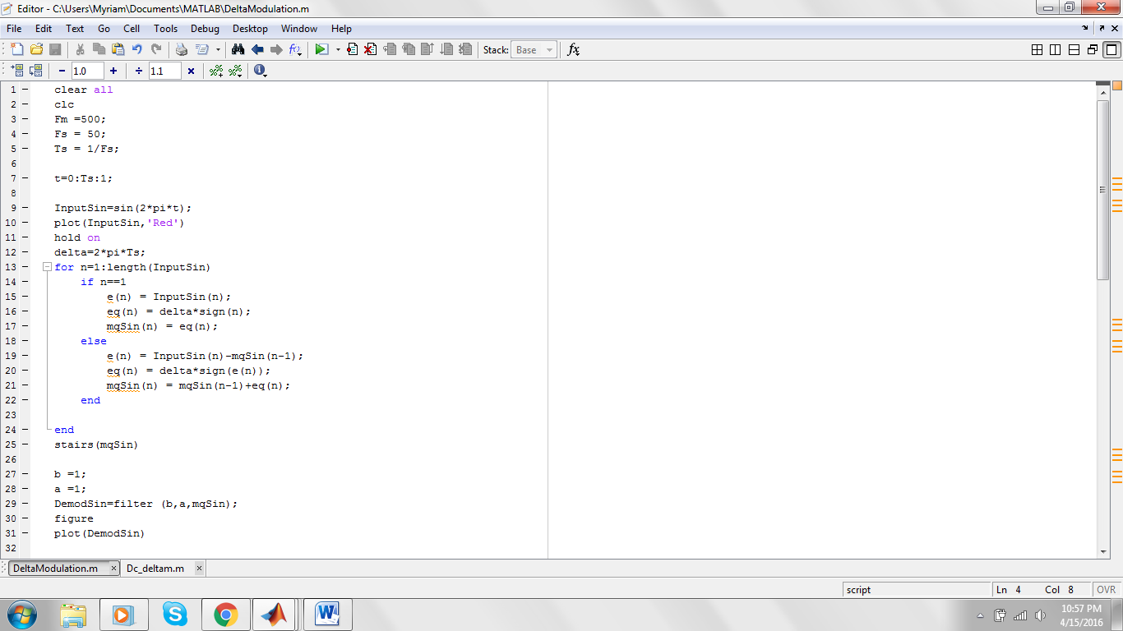

**Restore the Signal using a suitable Filter :**

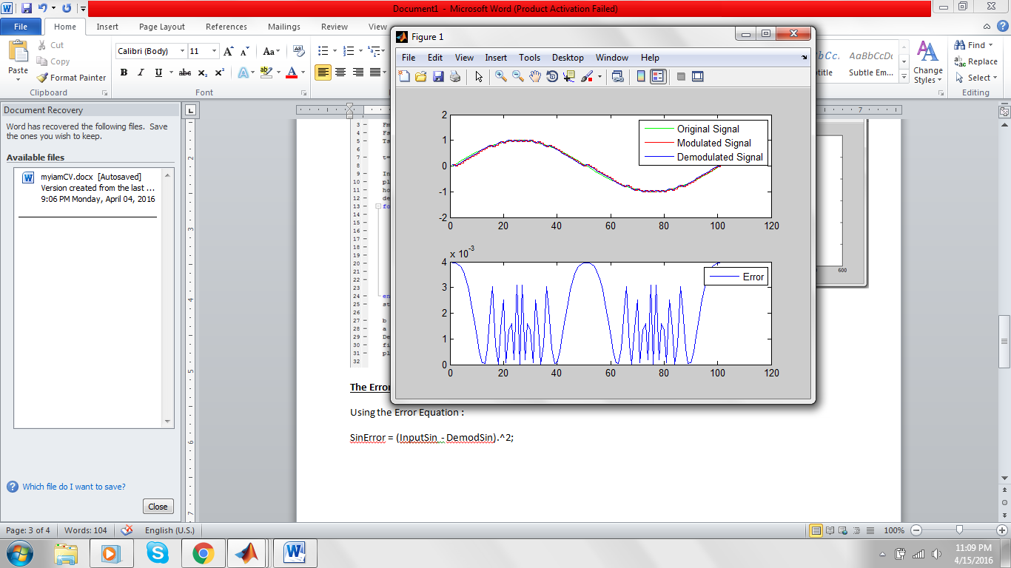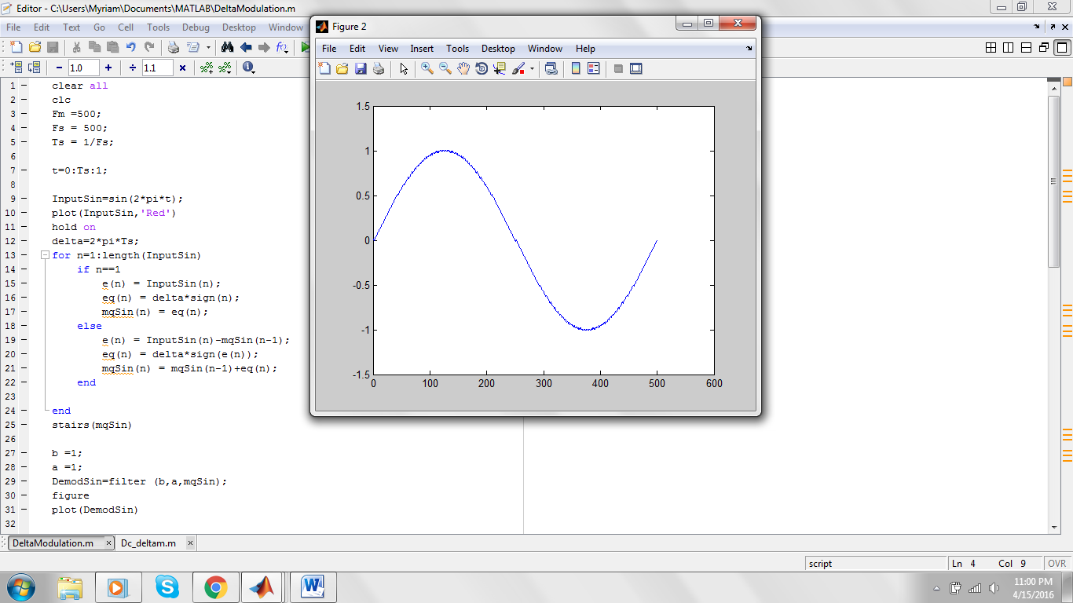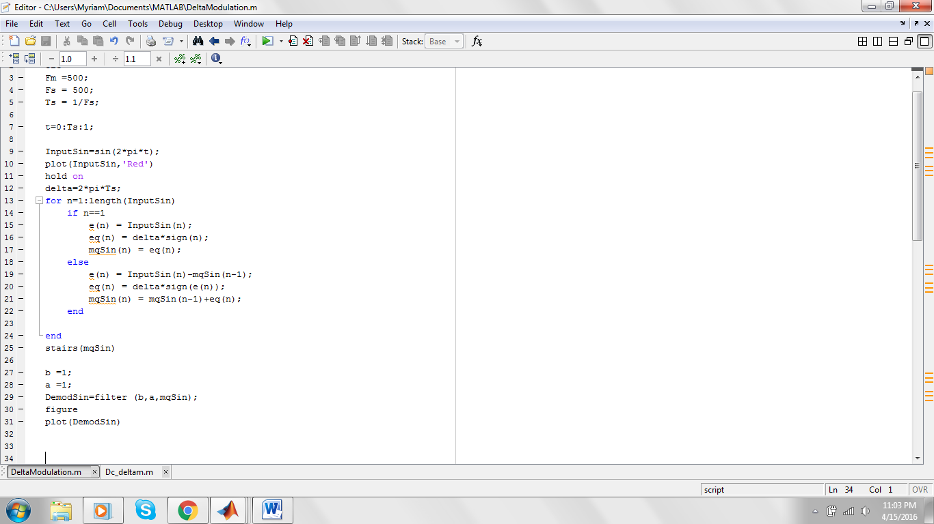

**The Error in the Signal :**

Using the Error Equation :

SinError = (InputSin - DemodSin).^2;

**// sour ll code kamel bl output**

**2. Repeat the previous steps (b-e) when the input is (for the same Ts and δ):**

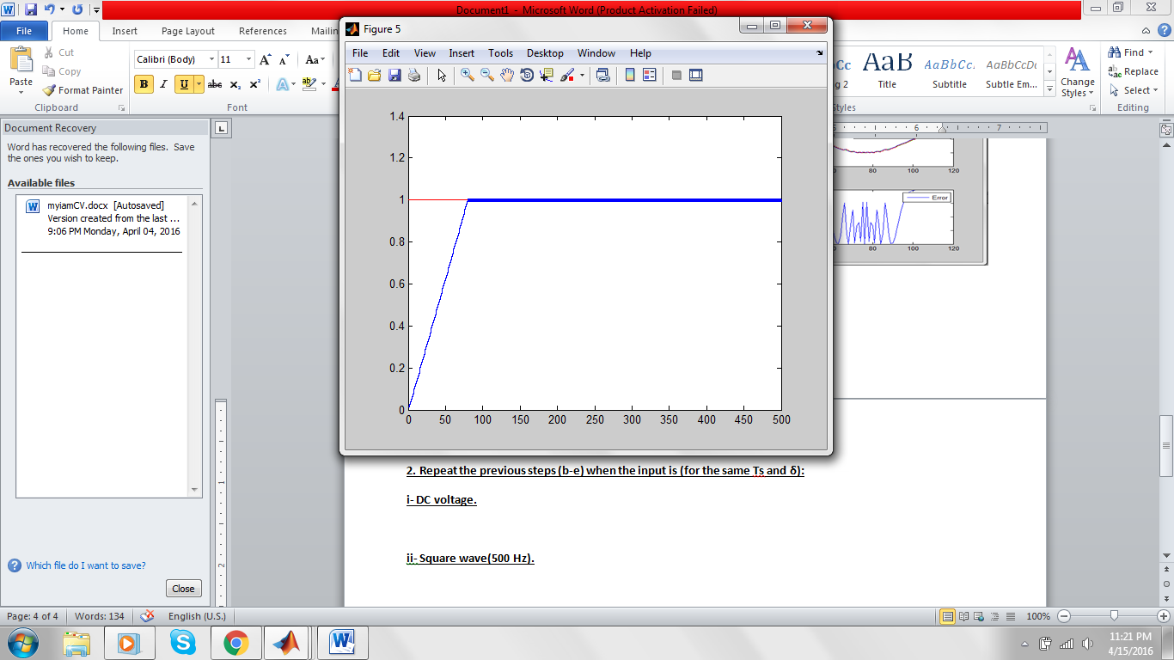**i- DC voltage.**

The Code for the Dc Delta Modulation :

InputDC= ones(size(t));

subplot(2,1,1);

plot(InputDC,'green')

hold on

for n=1:length(InputDC)

if n==1

e(n) = InputDC(n);

eq(n) = delta*sign(n);

mqDC(n) = eq(n);

else

e(n) = InputDC(n)-mqDC(n-1);

eq(n) = delta*sign(e(n));

mqDC(n) = mqDC(n-1)+eq(n);

end

end

stairs(mqDC,'red')

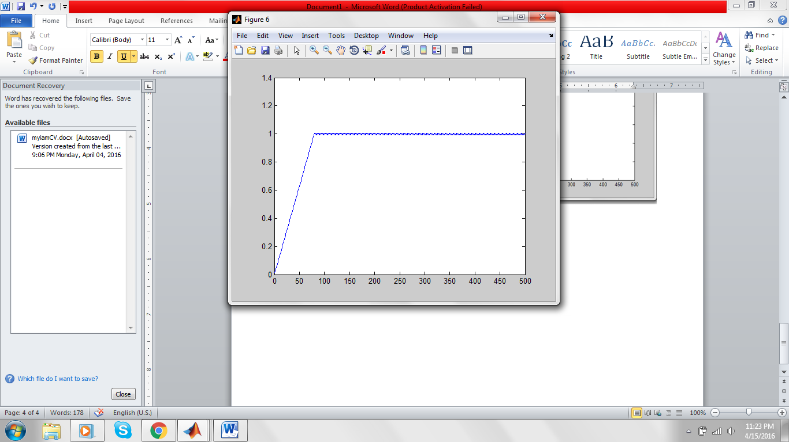**the demodulated Signal :**

**The Error Signal :**

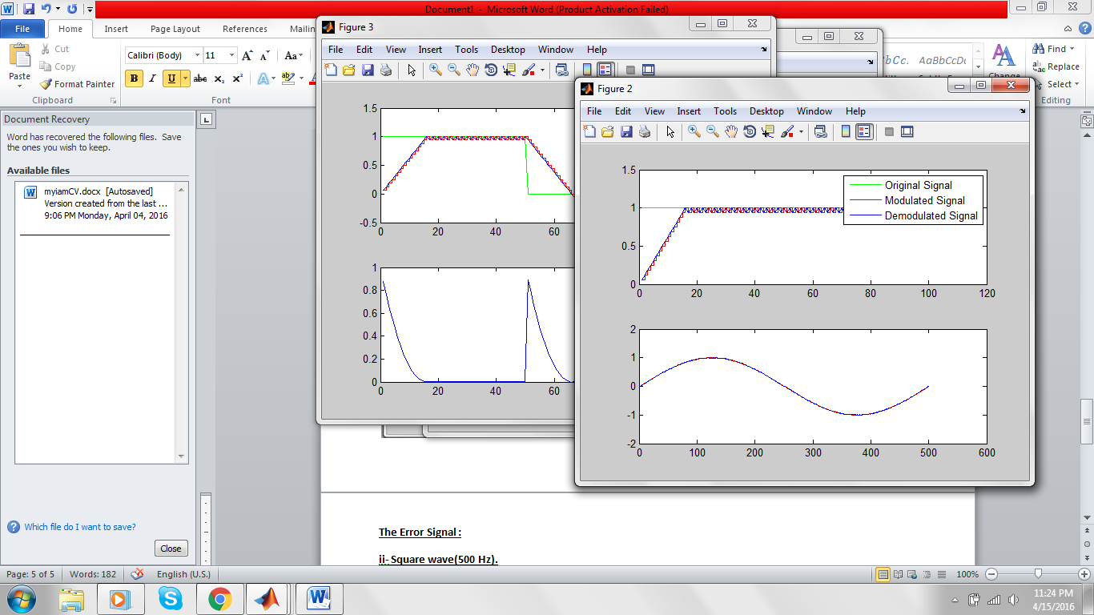

**//Soura l kol el code with comments**

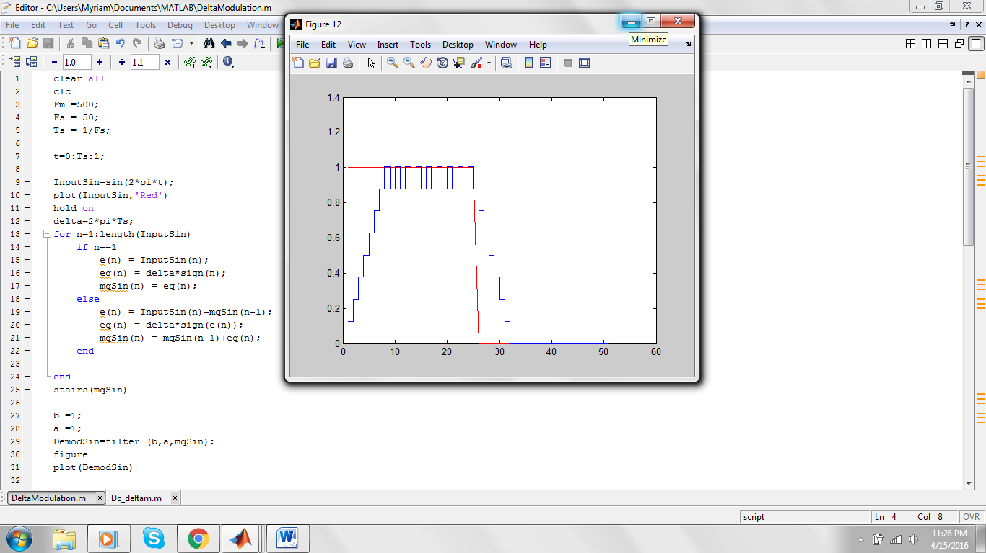**ii- Square wave(500 Hz).:**

**the Code :**

InputSquare= rectpuls(t);

subplot(2,1,1);

plot(InputSquare,'green')

hold on

for n=1:length(InputSquare)

if n==1

e(n) = InputSquare(n);

eq(n) = delta*sign(n);

mqRect(n) = eq(n);

else

e(n) = InputSquare(n)-mqRect(n-1);

eq(n) = delta*sign(e(n));

mqRect(n) = mqRect(n-1)+eq(n);

end

end

stairs(mqRect,'red')

**the Demodulated Signal :**

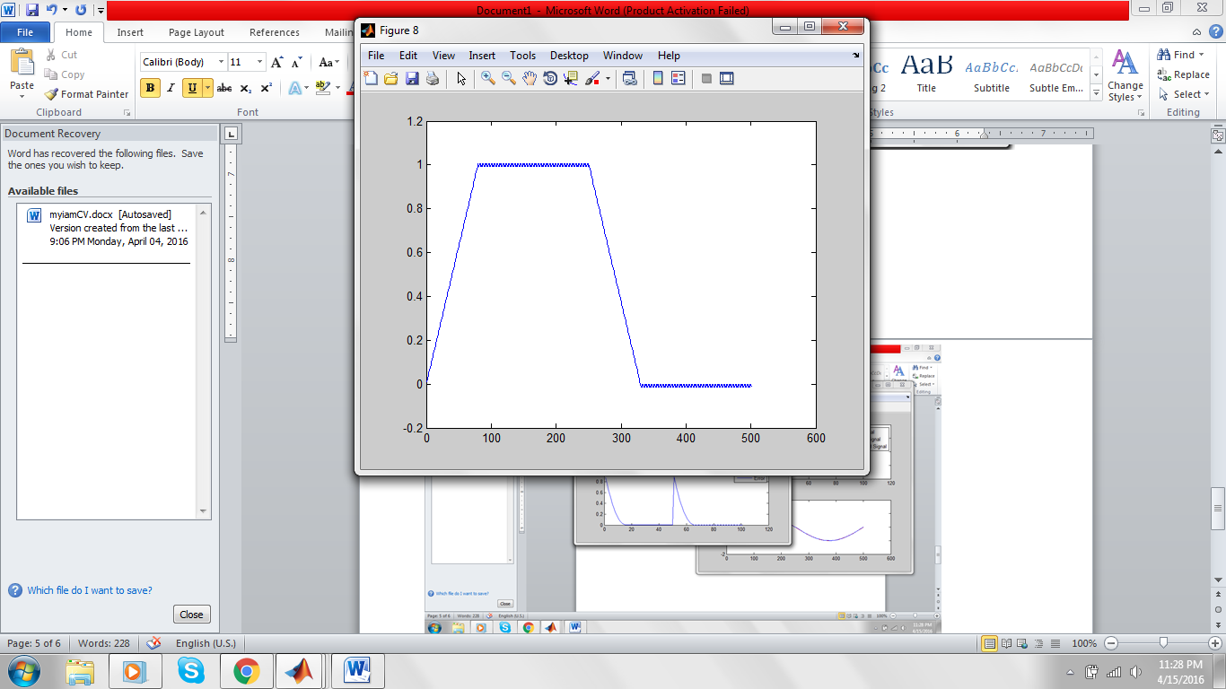

**The Error in the Signal :**

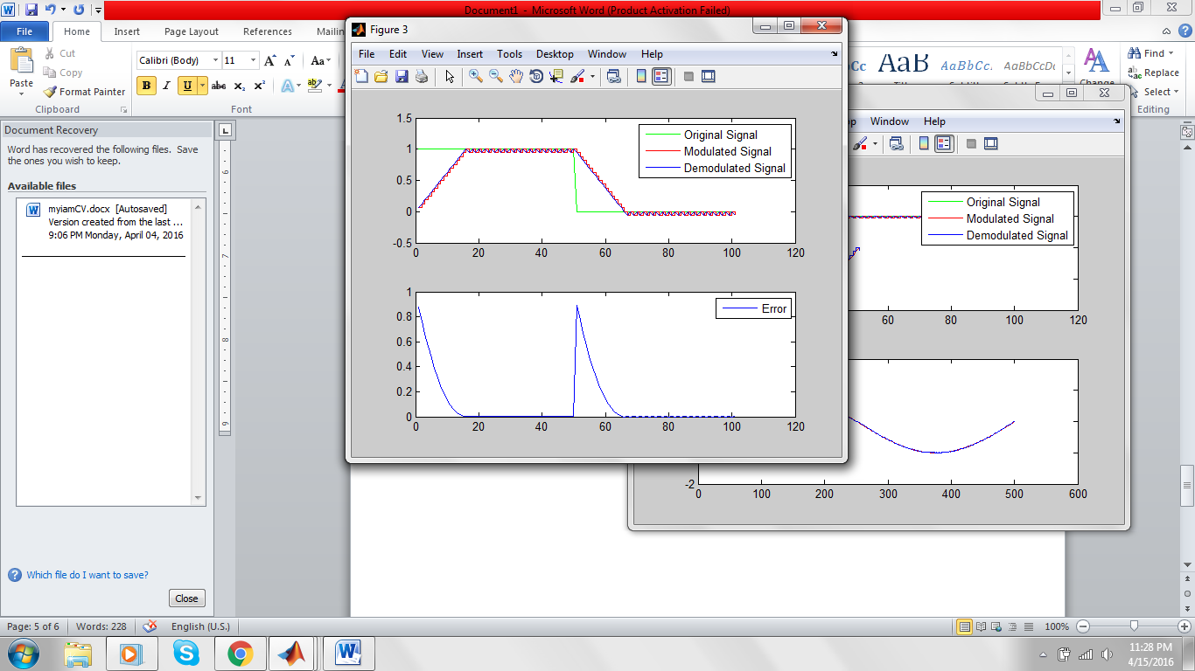

**// Soura ll Code kolo with Comments**

**(3) Repeat 1 and 2 when**

**i- δnew= 0.1* δold , while Ts is the same as in part 1:**

**ii- Tsnew= 0 .1*Tsold , while δ is the same as in part 1.**